IT Questionnaire
Table of Content

 | Topic
1 | Application implementation scope & vendor information
2 | Application overview, data flow diagram & interfaces requirements
3 | Client devices requirements
4 | Network requirements
5 | Server requirements
6 | Database requirements
7 | Data security requirements
8 | Data extract requirements
9 | Disaster recovery
10 | Implementation Work breakdown structure
11 | Ongoing Support requirements

- Application implementation scope & vendor information

Question | Vendor Response
Application scope of use for Memorial Healthcare System | Solution will be used across all Labor and Delivery Units at Regional, West and Miramar.
Vendor name | PeriGen, Inc
Application name & version # | PeriWatch Vigilance 2024.2.0
Vendor sales contact information | Zach Schooler  Director, Client Development  904-827-3610  Zach.schooler@perigen.com
Vendor support contact information | Andrew Krieman  Director, Technical Support Services  919-236-4353  Andrew.krieman@perigen.com

- Application overview, data flow diagram & interface requirements

Question | Vendor Response
Provide application overview. | PeriGen will be providing MHS with our proprietary "Vigilance" Maternal/Fetal Early Warning System. Constructed as a patient safety solution, "Vigilance" is an automated Obstetric Maternal/Fetal Early Warning System that is designed to work in tandem with your current EMR and Fetal Surveillance system. Vigilance provides Early Warning Remote and Central Monitoring, Notifications, HL7 EMR integration, Interfaces and Artificial Intelligence Analysis on Mother/Baby. The solution provides notifications to clinicians when maternal vital signs, fetal heart rate, contractions and labor progression surpass the thresholds set by each institution. In addition, our early warning system is able to notify the clinicians about concerning trends in maternal vital signs, FHR, and contractions, without requiring user input or validation. Vigilance also includes the ability to integrate your organization’s guidelines for interventions related to concerning fetal tracings, maternal vital signs and labor progression in the platform; this allows ease of access while the clinician is in the application or actively monitoring patients via the system. The platform is leveraging Microsoft standard technology and is fully installed at the health system on customer provided servers and workstations according to PeriGen provided specifications. PeriGen also will also provide comprehensive Professional Services to fully implement the product and support the Go Live. Post Go Live, the customer transitions to the PeriGen Support Team with 24/7 availability, located in Cary (Raleigh), North Carolina.
Application data flow | Client Fetal Monitor software will send all relevant tracings to the PeriGen Vigilance interface server where the data will be processed and posted into Vigilance. The Vigilance software then reads the data and determines the appropriate status for the patient.  At the workstation, clients have the option to receive notifications about patient status with the VNA (Vigilance Notification Agent) application. Staff is also able to view the Vigilance HUB board from their workstation that will provide an overview of all beds/patients for their facility. The HUB page also allows the staff to view a Single Patient tracing.  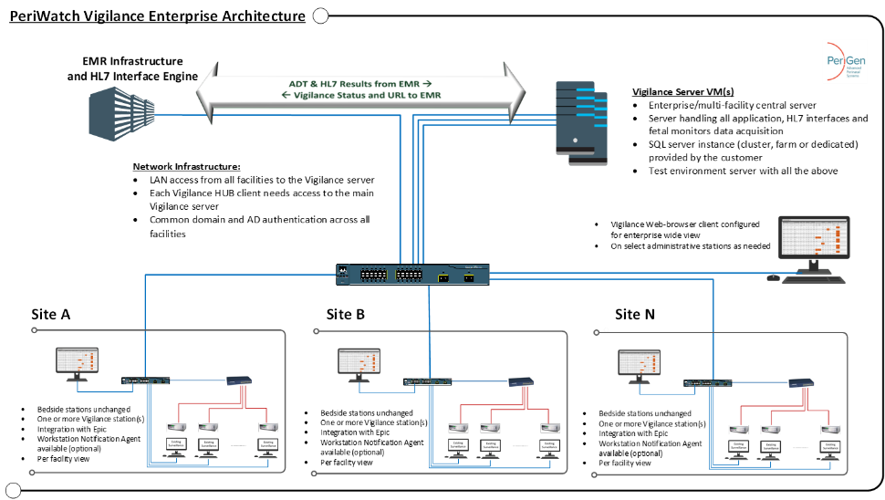
Will the proposed application interface with other MHS systems? (y/n) | Yes
Interface requirements | If interface is required, provide the following.  - 3  - HL7  - Individual interfaces for ADT, ORU and FM data acquisition.

- Client device requirements

Question | Vendor Response
Client devices requirements | Describe the Acceptable OS versions, and Manufacturer/Models/special features for all client devices required (such as Laptops, Workstations, Thin Client & Handheld.  Windows 10/11 (pro or above). All client devices to be used are existing or new stations in the OB areas.
Printing requirements | Describe the printing requirements to deploy the application / system being considered.  Only occasionally used. Such printouts (reports or tracings) follow standard printing guidelines. No special requirements assuming modern printers are being used (jet or laser)
Provide list of all the supported browsers | Google Chrome  MS Edge (Chromium)
If desktop application needs to be installed, is a MSI package available? | The Vigilance application is deployed via the browser. No installation required.  The PeriWatch Surveillance app is deployed using a directory that needs to be pushed to end-user workstations using standard IT tools (ex: SCCM or equivalent). The software then allows for auto-updating of client software from the server (permissions required).

- Network requirements

Question | Vendor Response
Describe network requirements. | The Vigilance server will need to have HTTP/HTTPS
Is site to site VPN required? If yes, please provide requirements documents. | No, the assumption is that MH will use SecureLink for remote support services.

- Server requirements

Question | Vendor Response
Virtual Server requirements | If virtual servers are required, provide the following information.  - Virtualization technology used  - Acceptable OS versions  - Manufacturer/Models/special features  - Local or SAN disk
Physical server requirements | If physical servers are required, provide the following information.  - Acceptable OS versions  - Manufacturer/Models/special features  - Local or SAN disk  Please refer to the same document embedded in the previous answer.
Cloud server requirements | If the application instance will be hosted in the cloud, provide the following information.  - Cloud provider  - Acceptable OS versions  Not applicable.

- Database requirements

Question | Vendor Response
Database requirements | Please provide database requirements

- Data security requirements

Question | Vendor Response
Authentication  - Active Directory Authentication  - SAML for single signon  - DUO MFA for Admin access and Remote access | Describe your company’s approach in meeting Authentication requirements.  The PeriWatch system is configured to connect to customer’s AD servers and provide access to authenticated users that are members of matching security groups configured within the application.  SSO is supported/integrated with Epic EMR. No SAML is supported.  There is no support for DUO MFA for clinical users on prem. PeriGen support access is performed with Azure AD credentials + MFA (assuming SecureLink is being used).
Account provisioning  - AD or AD group controlled  - Must be Manageable by Imprivata IDG | Describe your company’s approach in meeting account provision requirements  Fully managed by customer IT via Active Directory membership.
Data storage  - Must be stored in USA  - Must be encrypted | Describe your company’s approach in meeting data storage requirements.  The system if 100% on-prem, hence fully controlled by customer IT.
Retention Must meet State of Florida retention schedule parameters | Describe your company’s approach in meeting retention requirements.  The system if 100% on-prem, hence fully controlled by customer IT.
Activity logging Must log all user activity in compliance with FIPA and HIPAA standards | Describe your company’s approach in meeting activity logging requirements.  All activities in the application are logged to include user name, workstation, screen accessed, data view/updated and the time of the event.

- Data extract requirements

Question | Vendor Response
Will the proposed implementation require data extract from MHS? | No
If extract is required, provide the following.  - # of extracts  - Transfer method (SFTP,etc)  - Provide detailed extract specification (attach additional documents as appropriate) | NA

- Disaster recovery

Question | Vendor Response
Provide detailed description of application disaster recovery. | PeriWatch Vigilance infrastructure relies on MS SQL AlwaysOn clustering support (customer provided) and VMware HA or higher options along with coordinated backup of VM & databases by the customer. Configuration to be jointly determined as part of go-live activities.

- Implementation Work Breakdown Structure
￼ATTACHED

Activity | Vendor provided* (Y/N) | MHS resource | Estimated Hours
See Attachment | Yes

* if ‘N’, MHS to complete ‘MHS resource’ column

- Ongoing Support requirements

Support Activity | Vendor provided* (Y/N) | MHS resource | Estimated Hours
24/7 PeriGen Technical Support from Raleigh, NC | Y

* if ‘N’, MHS to complete ‘MHS resource’ column

